📘 Project Report

Project Title: Store Manager

Under Naan Mudhalvan Scheme

---

1. Introduction

The Store Manager project is a digital inventory and sales management system that helps small and medium businesses handle their day-to-day operations efficiently. The system manages stock, sales, billing, employee roles, and customer details in one place.

With the rapid growth of retail, there is a strong need for automation in stores to reduce manual errors and improve productivity. This project provides a user-friendly solution for shopkeepers, supermarkets, and wholesalers.

---

2. Objectives

To maintain real-time inventory with automatic stock updates.

To generate bills and invoices quickly.

To track sales, purchases, and profits.

To manage suppliers and customers in a single system.

To reduce manual record-keeping and errors.

---

3. Proposed System

🔹 Features

1. Login & Role Management – Admin, Staff, Cashier.

2. Inventory Management – Add, update, delete, track stock.

3. Billing System – Generate printed/e-bills for customers.

4. Sales Report – Daily, weekly, monthly analytics.

5. Supplier Management – Track purchases & vendor details.

6. Customer Management – Maintain customer purchase history.

7. Alerts & Notifications – Low stock, expiry reminders.

---

4. System Architecture

User → Application (Web/Mobile) → Database → Reports & Analysis

Frontend: HTML, CSS, ReactJS / Flutter

Backend: Node.js / Django

Database: MySQL / Firebase

Extra: Barcode Scanner / QR code integration

---

5. Modules

1. Admin Module – Controls users, reports, settings.

2. Inventory Module – Stock entry, stock-out, updates.

3. Billing Module – POS (Point of Sale), GST support.

4. Reports Module – Sales, profit, inventory summary.v

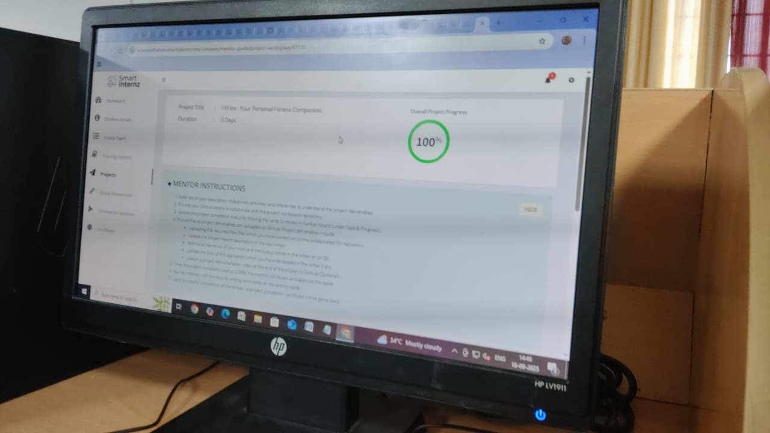

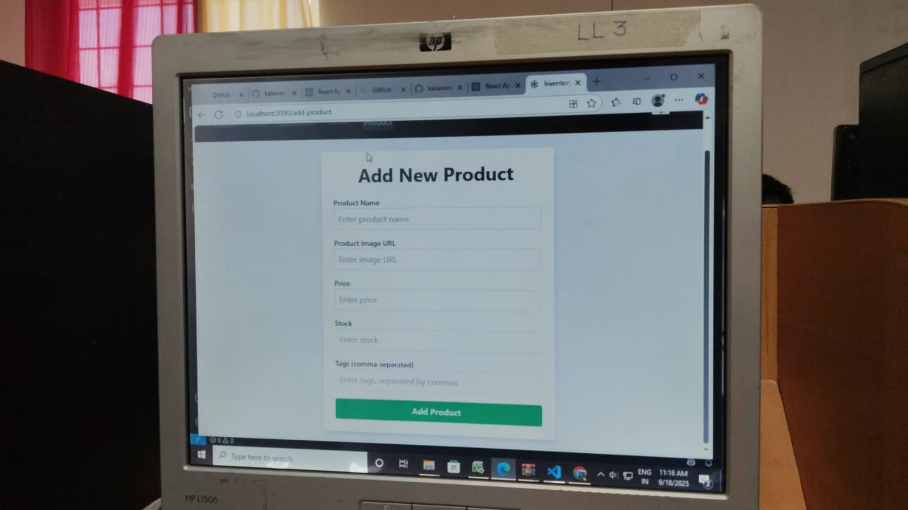

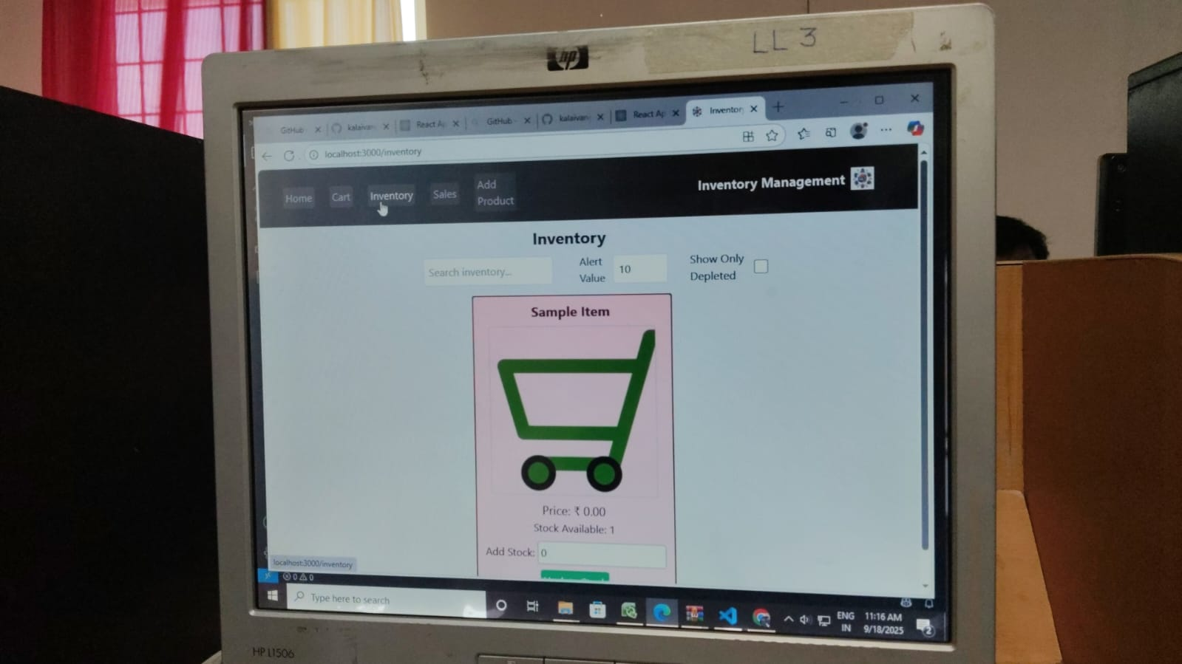

THANK YOU….!